* [CREATE](http://localhost/phpmyadmin/url.php?url=https://dev.mysql.com/doc/refman/8.0/en/create-database.html) [DATABASE](http://localhost/phpmyadmin/url.php?url=https://dev.mysql.com/doc/refman/8.0/en/create-database.html) mydbms;
* CREATE TABLE Country(id int PRIMARY KEY AUTO_INCREMENT, country_name varchar(50), country_name_eng varchar(50), country_code varchar(50));

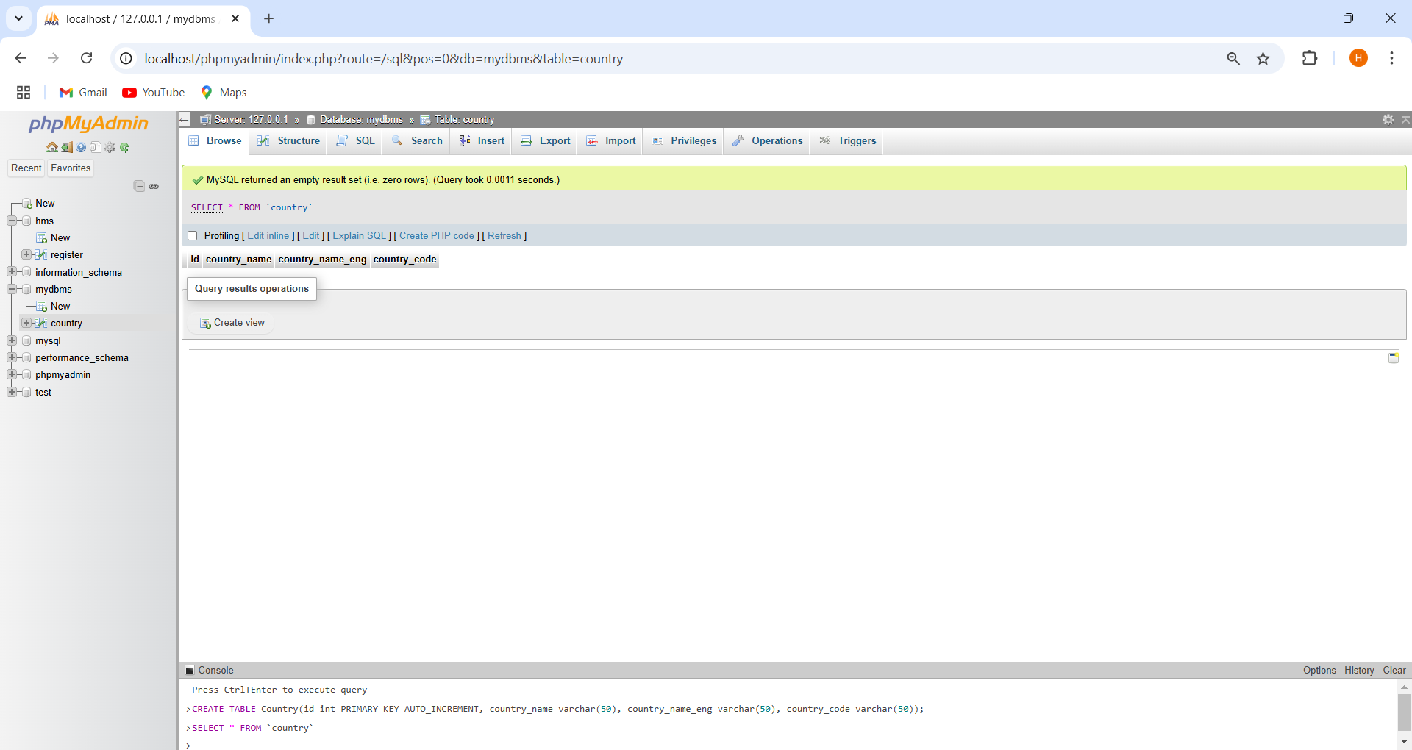

* INSERT INTO country(id, country_name, country_name_eng, country_code)VALUES(1, "Deutschland", "Germany", "DEU"),
* (2, "Srbija", "Serbia", "SRB"),
* (3, "Hrvatska", "Croatia", "HRV"),
* (4, "United States of America", "United States of America", "USA"),
* (5, "Polska", "Poland", "POL"),
* (6, "Espana", "Spain", "ESP"),
* (7, "Rossiya", "Russia", "RUS");

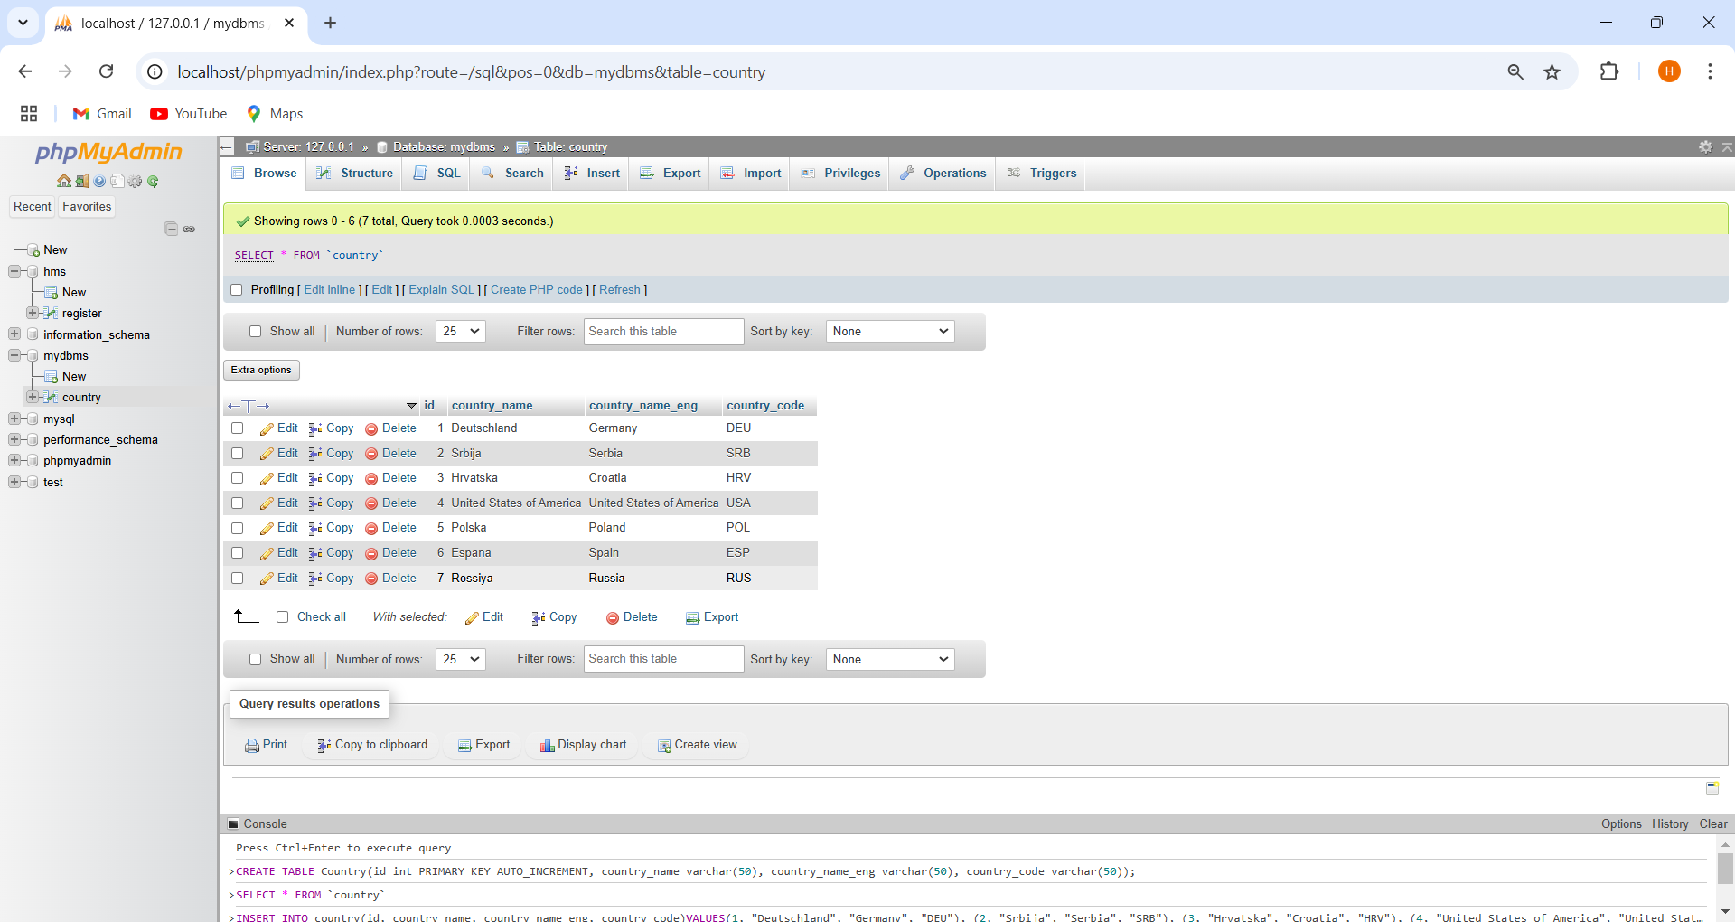

* CREATE TABLE City(id int PRIMARY KEY AUTO_INCREMENT, city_name varchar(50), lat varchar(50), city_long varchar(50), country_id int, FOREIGN KEY(country_id)REFERENCES country(id));

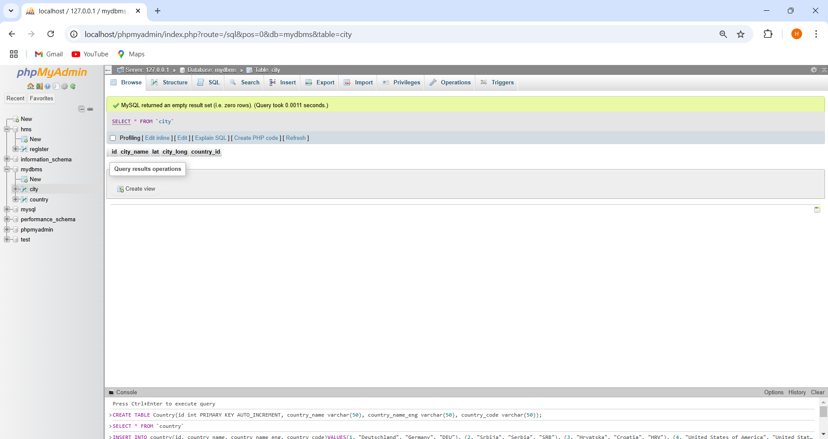

* INSERT INTO city(id, city_name, lat, city_long, country_id)VALUES(1, "Berlin", 52.520008, 13.404954, 1),
* (2, "Belgrade", 44.787197, 20.457273, 2),
* (3, "Zagreb", 45.815399, 15.966568, 3),
* (4, "New york", 40.730610, -73.935242, 4),
* (5, "Los Angeles", 34.052235, -118.243683, 4),
* (6, "Warsaw", 52.237049, 21.017532, 5);

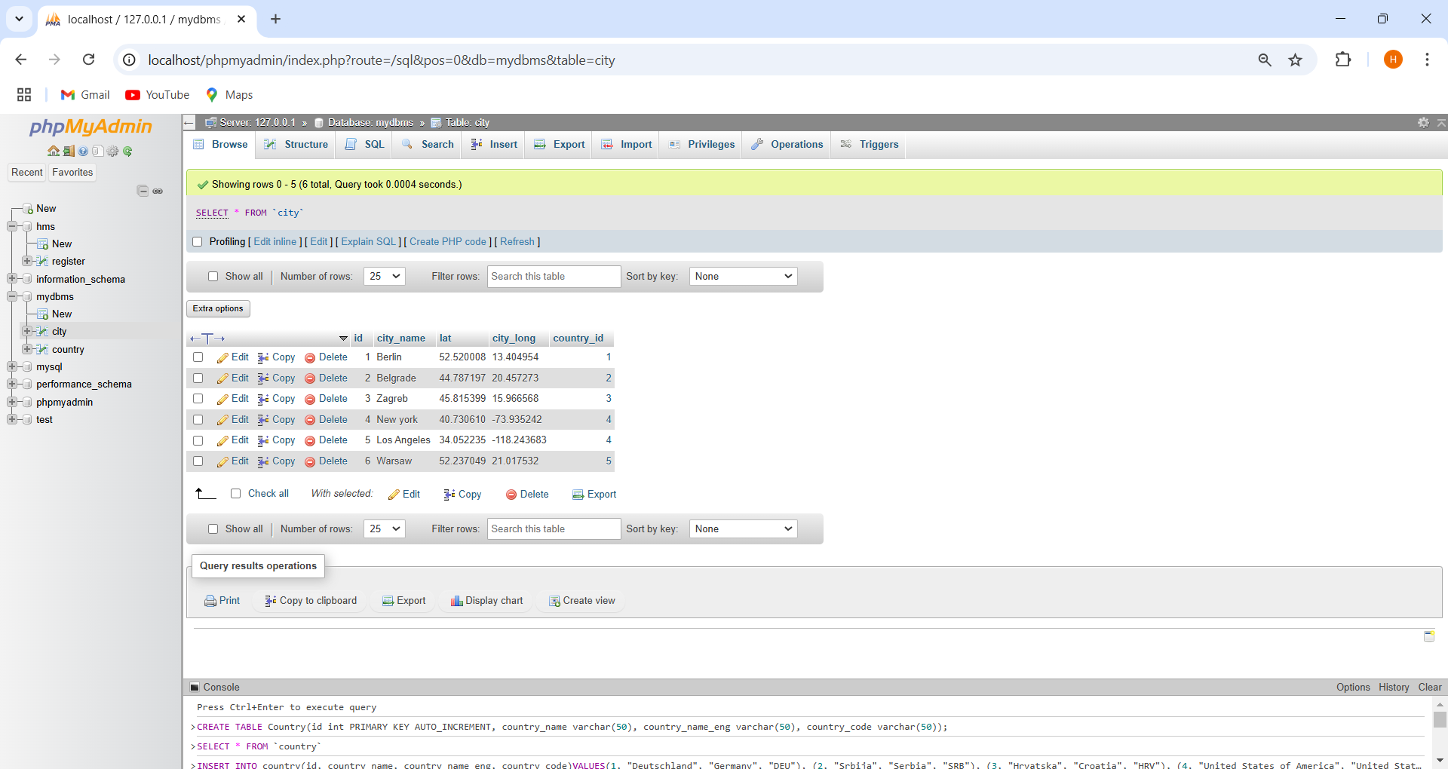

* CREATE TABLE Customer(id int PRIMARY KEY AUTO_INCREMENT, customer_name varchar(50),city_id int,FOREIGN KEY(city_id)REFERENCES city(id), customer_address varchar(80), next_call_date date, ts_inserted date);

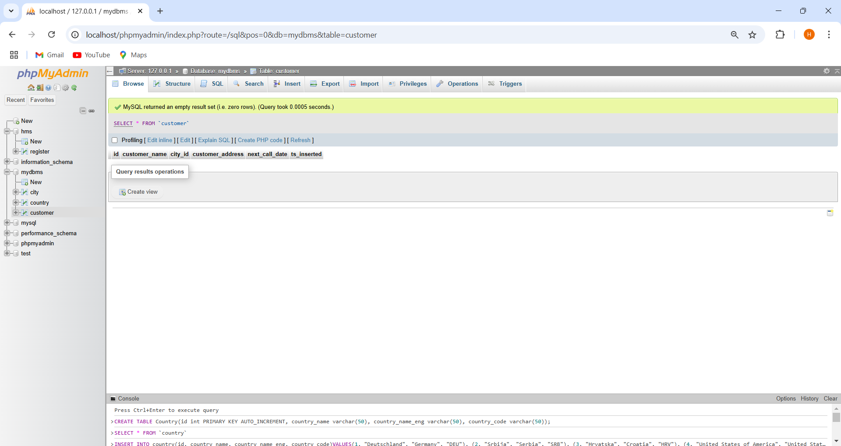

* INSERT INTO customer(id, customer_name, city_id, customer_address, next_call_date, ts_inserted)VALUES(1, "Jewelry Strore", 4, "Long Street 120", 2020-01-21, 2020-01-09),
* zz(2, "Bakery", 1, "Kurfurstendamm 25", 2020-02-21, 2020-01-09),
* (3, "Cafe", 1, "Tauentzienstrabe 44", 2020-01-21, 2020-01-10),
* (4, "Restaurant", 3, "Ulica Lipa 15", 2020-01-21, 2020-01-10);

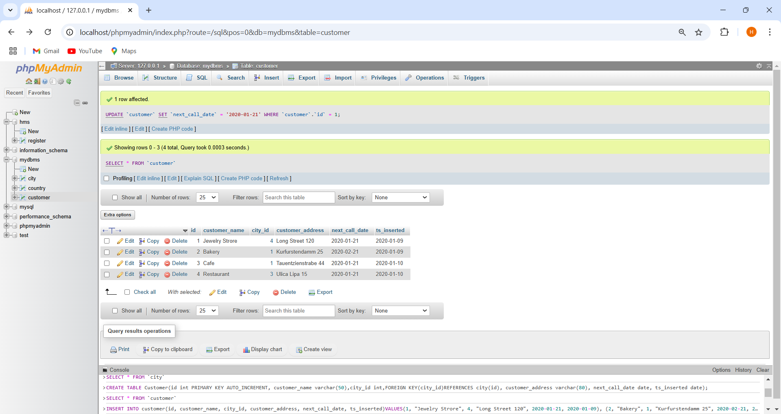

* SELECT country.country_name_eng, city.city_name, customer.customer_name FROM country LEFT JOIN city ON country.id = city.country_id LEFT JOIN customer ON city.id = customer.city_id ORDER BY country.country_name, city.city_name, customer.customer_name;

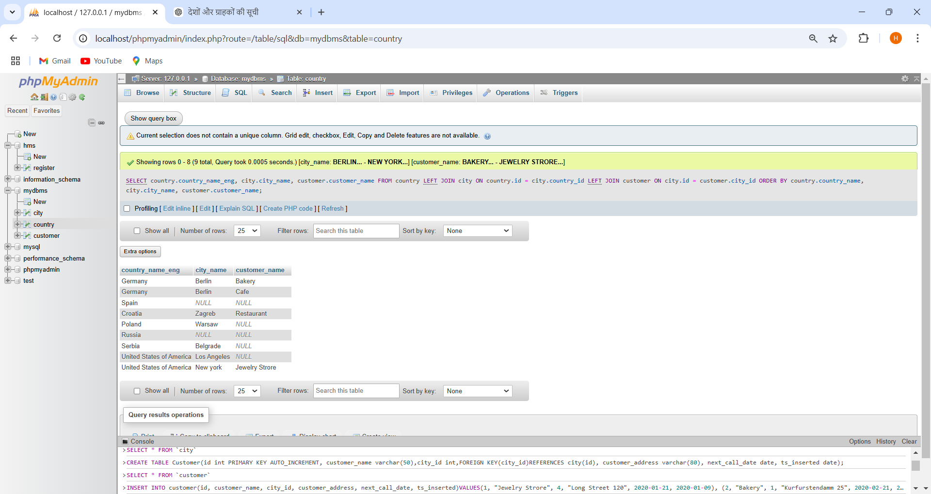

* SELECT country.country_name, city.city_name, customer.customer_name FROM country INNER JOIN city ON country.id = city.country_id LEFT JOIN customer ON city.id = customer.city_id ORDER BY country.country_name, city.city_name, customer.customer_name;

